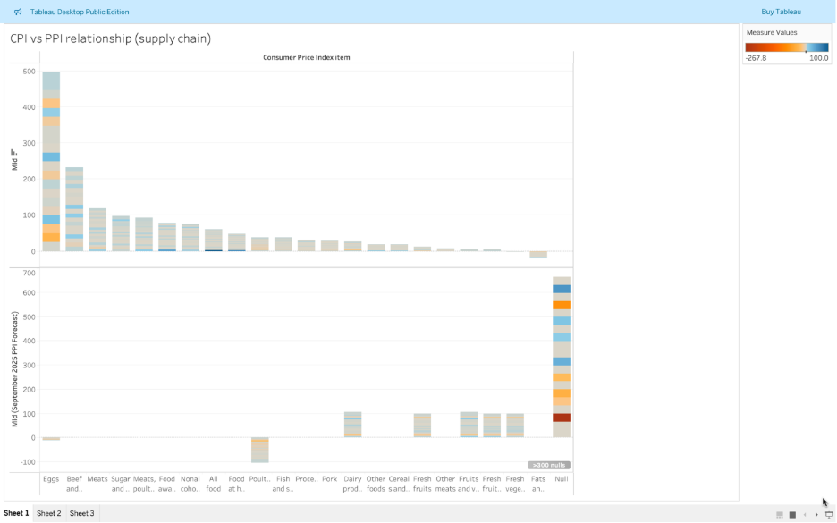
Goal: Compare expected Producer Price Index (PPI) to expected Consumer Price Index (CPI) across food categories. (Top is CPI, and bottom is PPI)
Chart 1 shows that producer price inflation (PPI) does not affect all food categories equally. Meats, dairy, and fats & oils show strong pass-through from producer to consumer prices, while fresh produce categories show weaker alignment, suggesting greater volatility and outside factors.

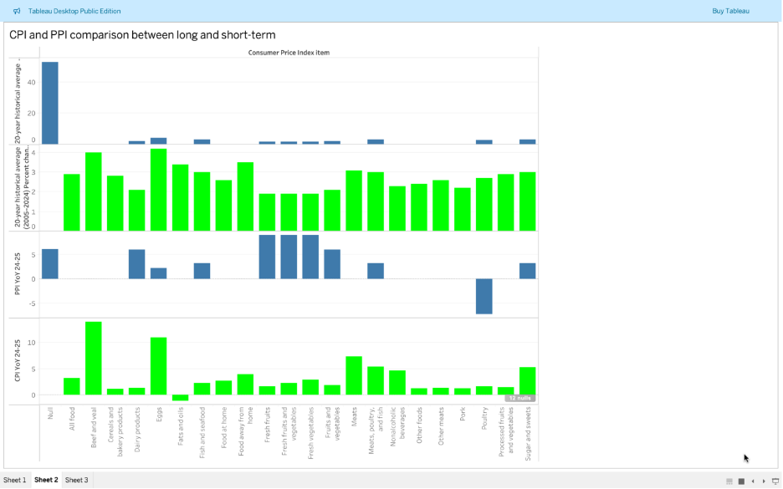
Goal: Show how PPI and CPI compare over long-term vs short-term trends. (Blue is the forecast and Green is the result.)
Chart 2 highlights which categories experienced the biggest differences between long-term inflation and short-term changes. Eggs, cereals/bakery products, and sugar show significant spikes relative to their 20-year averages, while fresh fruits and vegetables fell below historical norms. This reveals where consumers are facing the most (or least) pressure.

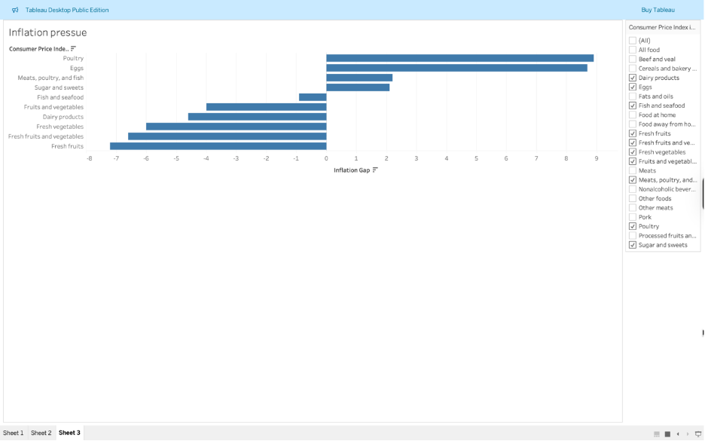
Goal: Show which categories have the highest gap between PPI and CPI, where producer prices are passed on to consumers.
Chart 3 evaluates forecast accuracy through the inflation gap. Forecasts underestimated inflation in poultry, eggs, and meats, while overestimating inflation for fruits and vegetables. This indicates uneven reliability in producer-to-consumer price forecasting.

